Lab 4
Muhammad Bilal
2022360

Submitted to: Maam Mahruk



task 1:
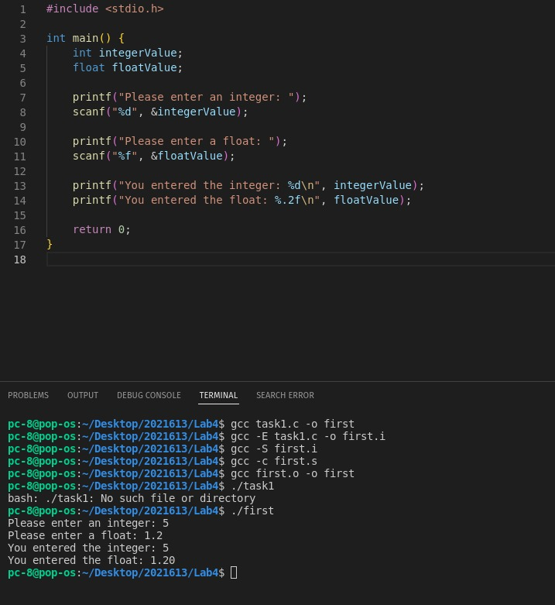
.

Task 2:
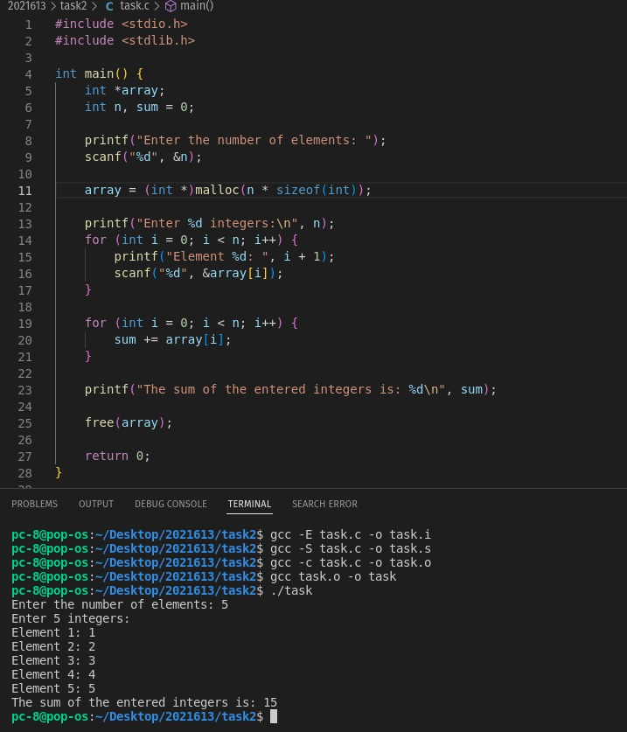
.

Task3:

Summary of the Compilation Stages
- Preprocessing (.i): The preprocessor handles directives and produces an expanded source file.
- Compilation to Assembly (.s): The compiler translates the preprocessed source code into assembly language.
- Compilation to Object (.o): The assembler converts the assembly code into machine code (object file).
- Linking (Executable): The linker combines object files and libraries to create the final executable.
